Jimmy Bean’s Wool Q4 Yarn Club pattern – slippers – Shanel Wu

# Pattern Information

## Title: Kickshaws

**Description:** “Art thou good at these kickshawses!” wrote Shakespeare, a slang term from him for something frivolously fancy and fun. These slippers will be a fun project, and make you feel fancy padding around during the colder seasons, but they are certainly not frivolous! Warm and practical, the three-part construction allows you to custom-fit the slippers. Lots of squishy garter stitch adds coziness and fun stripes!

## Sizes: XS [S, M, L]

baby [child/adult narrow, adult medium, adult large/wide] to fit sizes ___

## Gauge

22 sts x 30 rows = 4”/10cm (5.5 sts/in) in unblocked stockinette  
22 sts x 44 rows = 4”/10cm in unblocked, unstretched garter stitch

## Needles

Sample used US4/3.5mm to get gauge.

## Yarn

MC – Berroco Ultra Wool – 25 [90, 160, 210] yds totalCC – Malabrigo Rios – 25 [80, 130, 180] yds total

## Finished Dimensions and Fit

Foot width: 2 [3, 4, 5] ” / 5 [7.5, 10, 12.5] cm  
Foot length: 4 [7, 10, 13] ” / 10 [17.5, 25, 32.5, 37.5] cm as written, *can be adjusted between 3-5 [5-8, 8-11, 11-13] ” / 7.5-12.5 [12.5-20, 20-27.5, 27.5-32.5] cm*

To fit sizes Euro 18-24 [25-32, 33-43, 44-49]  
 US children’s 0-3.5 [4-13.5, -, -]  
 US women’s - [-, 5-11.5, 12+]  
 US men’s - [-, 3.5-10, 10.5-15]

## 

## Abbreviations

MC: main color  
CC: contrast color  
RS: right side  
WS: wrong side  
CO: cast on  
St(s): stitch(es)  
K: knit  
P: purl  
Sl1: slip one st, purlwise unless otherwise indicated  
Wyif: with yarn in front  
Wyib: with yarn in back  
Kfb: knit front back, single increase  
K2tog: knit 2 sts together, single decrease  
P2tog: purl 2 sts together, single decrease  
Psso: pass slipped st over, single decrease  
BO: bind off

## Special Techniques (Shanel can write/provide photos for a tutorial?)

“Pick up and knit” (left) / “pick up and purl” (right) diagrams:

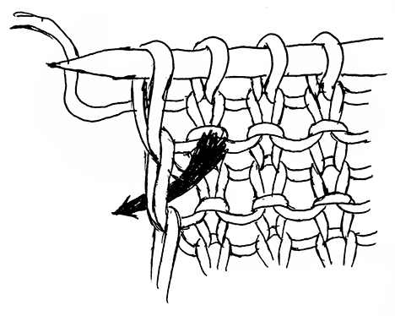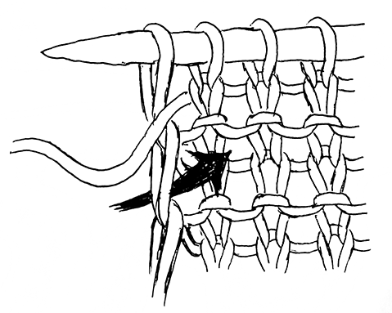

Cable cast on

Binding off in Part 3 (pictures in Slack)

# Pattern Instructions

## Part 1: Sole – 50g MC

Note: these instructions are written for the specified foot length. Foot length adjustments will be *italicized* in each part of the pattern.

Using MC, CO 3 [5, 6, 8] sts using the long tail method (or your preferred method). Work Row 1 a total of 6 [10, 12, 16] times to increase to 9 [15, 18, 24] sts.

Row 1: Sl1 wyif, k to 2 sts from end, kfb, k1.

Work sole in stockinette st by repeating Rows 2 and 3 an odd number of times, until piece measures 3 [6, 8.5, 11.5] ” / 7.5 [15, 21.5, 29] cm from CO *or until 0.75 [1.25, 1.25, 1.75] ” / 2.5 [2.5, 4, 4] cm short of the toe.* Approx 7 [19, 31, 43] repeats. End after a WS row.

Row 2 (RS): Sl1 wyif, k to end.

Row 3 (WS): Sl1 knitwise wyif, p to 1 st from end, k1.

Work Row 4 a total of 6 [10, 12, 16] times to decrease to 3 [5, 6, 8] sts. BO all sts and break yarn.

Row 4: Sl1 wyif, k to 3 sts from end, k2tog, k1.

## Part 2: Right Instep – 25g MC, 50g CC

With WS facing and beginning in the right-hand corner of BO edge, use CC to pick up and knit 2 [3, 3, 4] sts. Repeat Rows 5 and 6 2 [5, 6, 8] total times to increase to 8 [13, 15, 20] sts.

***XS only***

Next RS row: kfb, sl1 wyib, pick up and knit 1 st in selvedge, psso.

Next WS row: sl1 wyif, kfb, k1.

Row 5 (RS): Sl1 wyif, k to 2 sts from end, kfb, sl1 wyib, pick up and knit 1 st in selvedge, psso.

Row 6 (WS): Sl1 wyif, k to 2 sts from end, kfb, k1.

Join MC to work with both MC and CC in stripes. Repeat Rows 7-10 a total of 1 [4, 7, 10] times *or until you are roughly at the halfway point of Part 1’s sole*. For a tighter fit at the ankle, work one or two extra repeats. When switching between colors, leave old color in front of RS, and pick up the new color from the left, twisting the two yarns.

Row 7 (RS, MC): Sl1 wyif, k to 1 st from end, sl1 wyib, pick up and knit 1 st in selvedge, psso.

Row 8 (WS, MC): Sl1 wyif, p to 1 st from end, k1.

Row 9 (RS, CC): As Row 7.

Row 10 (WS, CC): Sl1 wyif, k to end.

Work Rows 7 and 8 once more. At the beginning of the next RS row and using the cable cast on, * CO 1 st in CC, CO 1 st in MC, repeat from * until you have cast on 6 [8, 12, 14] additional sts for 14 [21, 27, 34] sts total.

Work Rows 9 and 10 once more. Repeat Rows 7-10 an additional 1 [4, 7, 10] times, then work Rows 7 and 8 once more. Break MC. Continue working only Rows 9 and 10 in CC until all selvedge sts along the heel have been worked. There should be 7 [13, 16, 22] garter ridges around heel. Do not break CC, as you will continue using it in Part 3.

## Part 3: Left Instep – 25g MC, 50g CC

Join MC. Repeat Rows 7-10 (reprinted below) 2 [5, 8, 11] more times.

Row 7 (RS, MC): Sl1 wyif, k to 1 st from end, sl1 wyib, pick up and knit 1 st in selvedge, psso.

Row 8 (WS, MC): Sl1 wyif, p to 1 st from end, k1.

Row 9 (RS, CC): As Row 7.

Row 10 (WS, CC): Sl1 wyif, k to end.

Work Rows 7 and 8 once more, then break MC. Before starting the next RS row, hold the working needle WS together with the CO edge of Part 2 (WS faces WS). You will be working the CO sts together with the first 6 [8, 12, 14] live sts on the needle.

Next RS row (CC): Sl1 wyif. * Insert needle into the right-hand corner of CO edge as if to purl, picking up both legs of the edge, then p2tog with next live st. Pass first st over second st to bind off one st. Repeat from * , continuing to bind off until 8 [13, 15, 20] sts remain in total. K across the remaining sts to 1 st from end, sl1 wyib, pick up and knit 1 st in selvedge, psso.

Next WS row: Sl1 wyif, k to 1 st from end, sl1 wyif, pick up and purl 1 st in selvedge corner (make sure the selvedge st is in MC), psso.

Rejoin MC. Work Rows 11-14 1 [4, 7, 10] total times *(or the same number of repeats as Part 2)* until you reach the toe.

Row 11 (RS, MC): Sl1 wyib, k to 1 st from end, sl1 wyib, pick up and knit 1 st in selvedge, psso.

Row 12 (WS, MC): Sl1 wyif, p to 1 st from end, sl1 wyif, pick up and purl 1 st in selvedge (selvedge st will be CC), psso.

Row 13 (RS, CC): As Row 11.

Row 14 (WS, CC): Sl1 wyif, k to 1 st from end, sl1 wyif, pick up and purl 1 st in selvedge (selvedge st will be MC), psso.

Break MC. Continuing in CC, work Rows 15-16 3 [5, 6, 8] total times until you have 2 [3, 3, 4] sts remaining.

Row 15 (RS): Sl1 wyib, k to 3 sts from end, k2tog, sl1 wyib, pick up and knit 1 st in selvedge, psso.

Row 16 (WS): Sl1 wyif, k to 3 sts from end, k2tog, sl1 wyif, pick up and purl 1 st in selvedge (selvedge st will be CC), psso.

***XS only***

Work Row 15 once more.

Last WS row: k2tog, sl1 wyif, pick up and purl 1 st in selvedge, psso.

Break yarn, leaving a 6”/15cm tail. Using the tail, sew the remaining sts to the front to close the toe. Repeat from Part 1 for second slipper.

## Finishing

Weave in all ends. There may be a small hole at the front of the ankle where the CO in Part 2 and BO in Part 3 meet, so use the ends left there to close up any gaps. Block if desired, though I won’t judge if you don’t!